Stable block – No. 2, The Square, Ardkinglas

i. General

The last building to be surveyed forms part of the square which is the original 18th century quadrangular stable block relating to the early Ardkinglas House, since demolished. There is a date stone within the courtyard of 1764. This building appears to be overall essentially an 18th century complex and it is clear that it was very substantially renovated and modified by Lorimer, most likely in the first decade of the 20th century. The building overall is harled internally, within the courtyard and externally. This obscures much of the archaeological evidence for its evolution and modification. The principal entrance to the stable, this is evidently part of the original 18th century arrangement.

ii. External elevations

The exterior of this stable block is harled all the way round, internally in the courtyard and externally as mentioned before. There are well-preserved remains of a deep cream limewash in two coats with a secondary layer of white, limewash or paint, over that. It all appears to be of the Lorimer period. It seems clear that Lorimer reroofed the entire complex, giving it a characteristic bellcast profile at the eaves, slated with Scots slates and lead flashings. The rainwater goods are cast-iron and are probably of his period as well, including some good details such as a heavily moulded hopper head on the south elevation.
The unit that is described here in detail is No. 2, The Square, which is a dwelling occupying the north-west corner of the stable quadrangle. It is accessed on its north side via a lean-to porch erected in the 1970s. This is wood-framed and clad with cedar shingles externally, under a shingle roof. The entrance to the north is slightly offset to the west and there is a utility room on its east side, this lit by a window to the north. The 1970s lean-to porch is concrete floored within and lined with plasterboard internally.

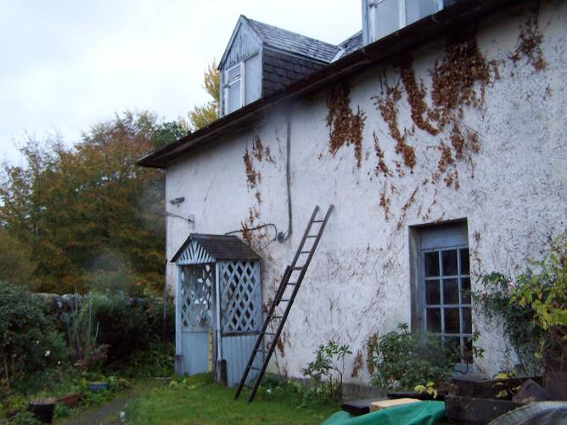
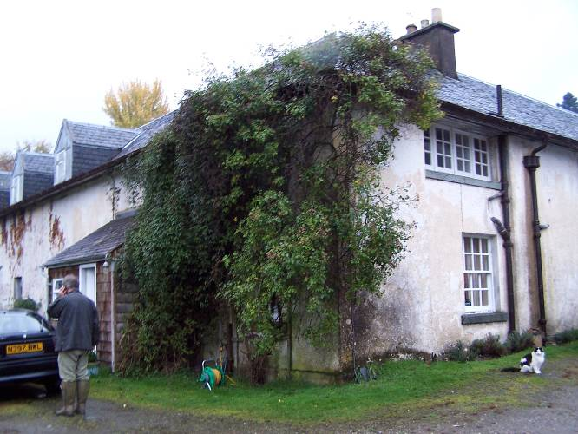

Figure 42 and 43 – NW corner of Stable block, containing unit No. 2 (left), original porch to east of Garage cottage (right).

iii. Interior

The main entrance had been originally immediately external before this porch was built. The Garage Cottage whose main entrance is on the south side, retains a little bit further east from No. 2 an earlier porch that may be what had been on No. 2, The Square originally. Perhaps the porch is a Lorimer period addition. The main entrance through a substantially-built, framed door, boarded below and glazed above with three-by-two panes. The boarded panel of tongue-and grooved vertical boards contains a substantial box lock within with later handles, a chunky section, chamfered profile. The entrance gives access directly into a small stair hall. This is panelled throughout on the walls with tongue-and-grooved boarding with a slight rebate at the joints. The skirtings are of cement, floored with cement scores to suggest large quarries. The ceiling contains a small applied timber cornice. A straight stair rises up to the south in a single flight from the south-east corner of this entrance hall. On the west side, at the base of the stiar, there is a small section of handrail, this with a squared newel and ogee top.

On the west side, at the foot of the stair is an entrance leading into the living room. This has a four-panelled door with plain panels within, on both sides, and a wonderful latch, very heavily made of solid brass and detailed with a curly handle. The handle of the door is of characteristic Lorimer detail and this same detail and the panelling arrangement of the door etc is seen throughout the interior. The living room is lit by a sash-and-case window, six-over-six in the west wall, slightly offset to the north . To the south of this is a press with a four-panelled press door. In the south wall there is a fireplace, slightly offset to the west. This formed of cemented fire bricks. The fireplace itself sits upon, what appears to be, an earlier hearthstone which is more substantial, and much wider than the fireplace. This doubtlessly relates to the earlier fireplace in this position. There is some scarring on the hearthstone which is of cement, suggesting the former presence of what may have been a kitchen range. This may have been similar to the one that still exists in the kennels. On the east side of this is a four panelled door, not of the characteristic Lorimer detail, but rather a late 19th century one with planted bolection mouldings. The interior is boarded up with vertical tongue-and-grooved boarding matching the boarding in the hall. This is to the north-west and east of the area included in the room. The lower part of the under stair area is framed in and there is a small cupboard door with brass handle of similar Lorimer-type detailing. At the west end of the north wall is an entrance into the kitchen that occupies the north-west corner of the cottage. This may have been the original pantry interior. Along the west wall is a three door sliding door cupboard arrangement. This is detailed with deep finger handles of solid brass, fixed to the front of these low shelves. At the base of the sliding doors is a hinged shelf that folds up and in this position can be supported by flaps that hinge out themselves. The north end of the shelf has been trimmed to accommodate the existing sink units along the north wall. The walls of this room are plastered internally with a hard cementitious plaster. All the arises around it and the angles of the wallhead are also rounded with no cornice. In the east wall there is a further four panelled door with brass latch leading to a small pantry room that is shelved out to the east and south. It has a small window of three panes to the north; the upper part of which is a hinged panel that folds down inwards. This interior is similarly plastered as the kithcen, scored out concrete flooring throughout.

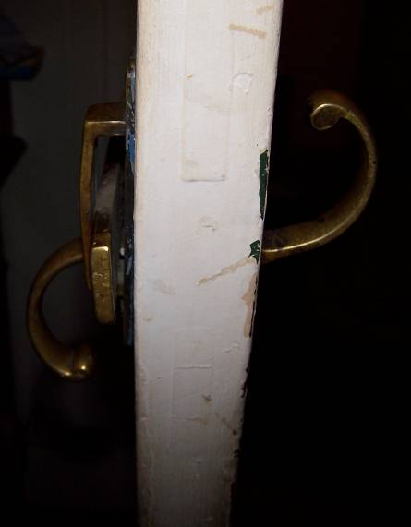
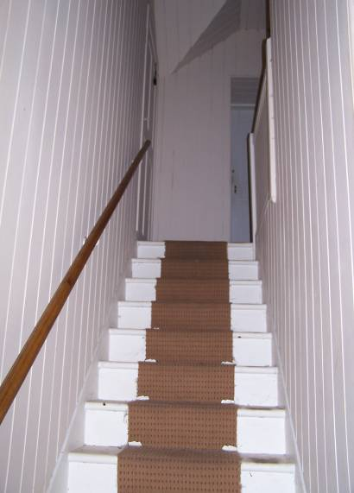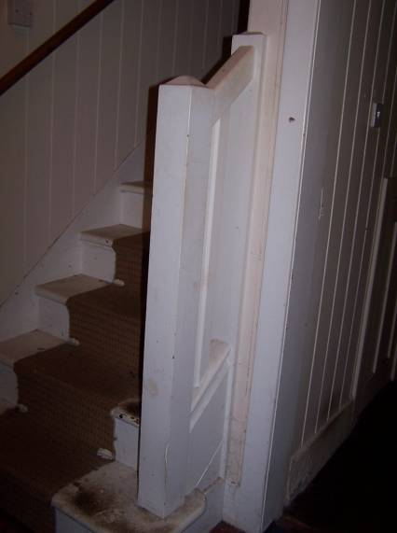
Figure 44, 45 and 46 – stair leading up from entrance hall (left), foot of stair and railing (centre), brassdoor handle, Lorimer-period (right).

The first room described as a living room would actually be better called the breakfast room. At the east end of the south wall an entrance leads into a further large room. This has been partly partitioned off with a studwork partition somewhat curiously running at a slight diagonal, forming a passage on the east side leading to an entrance that gives into the courtyard of the square. This again with a Lorimer-period door, glazed above, two-by-three, framed and tongue-and-grooved boarded below; again with a large brass latch as elsewhere. The secondary partition has a door at its entrance into the remainder of the ground floor space at the south end. The door itself of six panelled detail with a fillet-and-ovolo moulding on the one side and the principal side with raised and fielded panels, again with a fillet-and-ovolo moulding. This may be of late 18th century date. The former unified ground floor room retains its panelling throughout and on the west side of the partitioned area this has not been overpainted, but is simply varnished and, as elsewhere, it consists tongue-and-grooved boarding with a rebate at the joint. This is all in very good condition and has its original finish. It rises up to a wooden cornice. The ceiling is plastered in cementitious plaster. A principal joist runs across and is plastered over to give it a sort of curved angles and corners. In the centre of the north wall is a projecting chimneybreast. This retains its fireplace with a wooden surround and overmantel and apparently stone within. The hearth stone survives, but the whole has been subsequently infilled with a smaller fireplace of cemented firebricks and a later raised hearth. The floor in here is of cement that has been scored out to look like large quarries or very neatly cut sandstone flags. These are 18.5” square. The window in the west wall is not of sash-and case, but has a fixed frame below, three-by-two and an opening hinged upper section of three-by-one panes, this hinged below. Towards the east end of the south wall is a shelved recess which appears previously to have been an entrance, since blocked off. The panelling of the room itself runs into this. The shelves are clearly much later.

The straight flight of stairs rises up to the first floor where there is a landing and first floor hall area. All of this is cement/concrete floored, which extends throughout the level. The stair landing area is entirely lined out, ceiling and walls, with the same tongue-and-grooved boarding as seen elsewhere. All doors to the rooms are four panelled; again as elsewhere with large brass latches. The architraves again are simply detailed with a rounded inner and outer angle. The landing area is partly boxed in to the south-west and there is an airing cupboard with the hot water tank beneath, these separately accessed by their own doors. At the head of the stair on the east side there is an entrance. Rather curiously this opens into an area that is partly walled over lower down. This leads up to a small vestibule area and thereafter a chamber in the upper part of the building, properly within the north side of the stable quadrangle. This is concrete-floored throughout. The vestibule leads into a large empty chamber without individual features. The walls are cemented and the ceiling which is coombed to north and south is lined with hardboard. According to the present owner, this had apparently been latterly Miss Anastasia Noble’s bedroom. Dot, however, remembers that Anastasia’s bedroom was the upper upstairs room at the south-west corner. She cannot remember that the upper loft area was used as a bedroom, but recalls that plays were staged in that room when she was a child.
The door between the vestibule and the main part of the room itself is of high quality, a six panelled door with raised and fielded panels on one side, painted on white on one side. The other side without the raised and fielded panels still retains its scumbled graining and the moulding detail is a deep fillet-and-ovolo. The door itself is not pegged and appears to be of 19th century date.

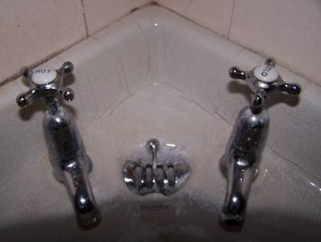
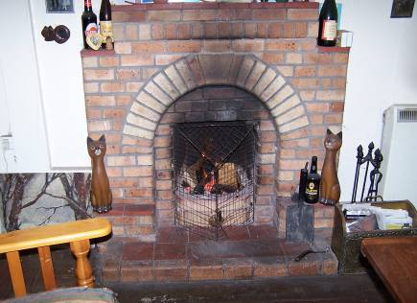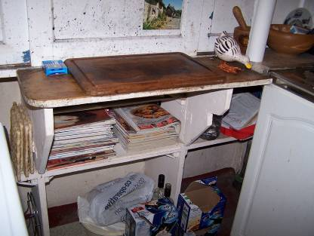

Figure 47, 48 and 49 – fire place in breakfast room (left),cupboard on W wall of kitchen (centre), tap
details in SW bedroom (right).

At the head of the stair continuing south in the centre of the south wall, an entrance leads into a bedroom. This again is fully lined out with boarding of same detail as elsewhere. The room is slightly coombed to east and west and lit by a broad window in the west wall; this of three panels separated by mullions. Each panel is of two-by-three panes, the southern and the centre of which are hinged and are detailed with nice wrought latches. In the centre of the north wall is a small fireplace. This is built of firebricks of small dimension with a raised hearth area below. It is possible that this is not original to the room, possibly of late 1930s or even post-war date. A good early 20th century Shanks corner sink is placed in the north-west corner. To the west of the stair landing is an entrance into the bathroom. This is fully lined out and boarded. ceiling and walls. with a slight coombing to the west. Along the south side is an early cast-iron bath with good brass taps and waste lift, enamelled, soap dish etc.; all very good period pieces. The taps have ceramic tops with transfer printed hot and cold etc.; each one saying: “Shanks & Company Ltd, patentees”. The enamelled bathtub itself is of a peppermint green hue.

An entrance to the north off the stair landing gives into another bedroom. This at the north-west corner of the upper cottage. It is similarly lined out and boarded within, coombed to the west and north. At the angle of the coombing is a small applied timber cornice of ovolo detail. A broad window in the west wall is of similar detail to the other bedroom at this level. At the north end of the east wall is an entrance giving into a walk-in wardrobe or clothes cupboard. Again, this is fully lined out with boarding, in this case unpainted but retaining its original varnish finish and brass coat hooks within etc. On the floor of this room is a linoleum faux carpet. This is of repeated flower pattern in greens and pale orangey browns, mint green.

This terminates a day in the rain in deepest Argyll, and is the last house recorded as part of the first phase of Our Houses – Their Stories for Here We Are.

1586.00/TA/BG/ET/TR
2.11.10; completed 28.3.

